BIT 4107 – Mobile Application Development
ENHANCED PROFESSIONAL STUDENT LOGBOOK
Student Name: _FAITH NJERI NDEGWA_____________________________
Admission Number: _ ____________ BIT/2024/54252_________________
School/Faculty: ________MKU______________________
Programme: _____ Mobile Application Development ____________________
Academic Year: ________3rd YEAR_____________________
Semester: __________2___________________
Lecturer: ___________MICHAEL NYORO___________________
Phone Number: ________0790661387______________________

Instructions
This logbook is used to document weekly learning activities, practical exercises, skills acquired, challenges encountered, solutions applied, and reflections. Students should complete all sections every week.
Each week to follow remarks in week 1 section.

Autogenerated Table of content

Week 1: Introduction to Mobile Application Development

Practical Activities Undertaken
Installation process
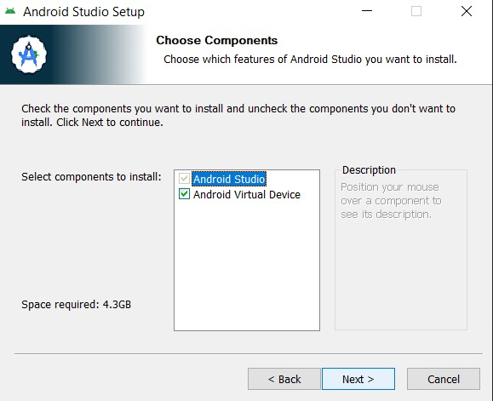

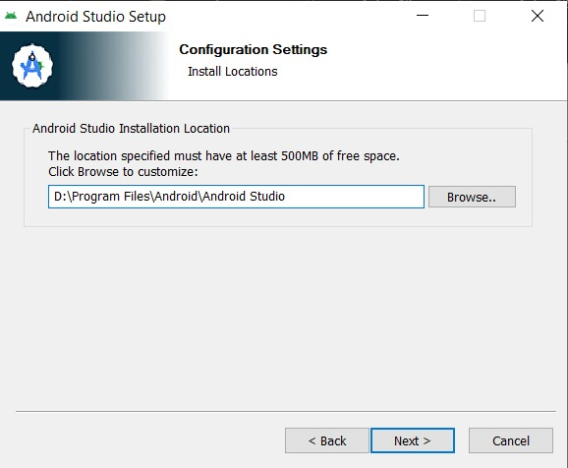
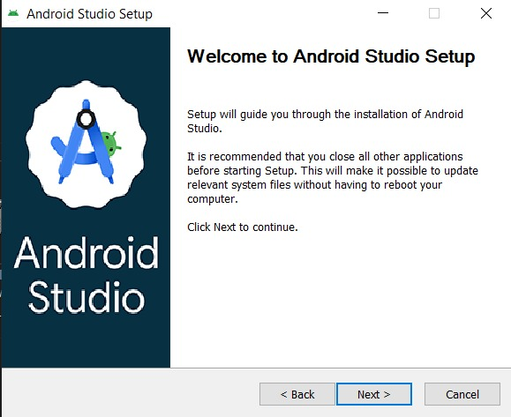

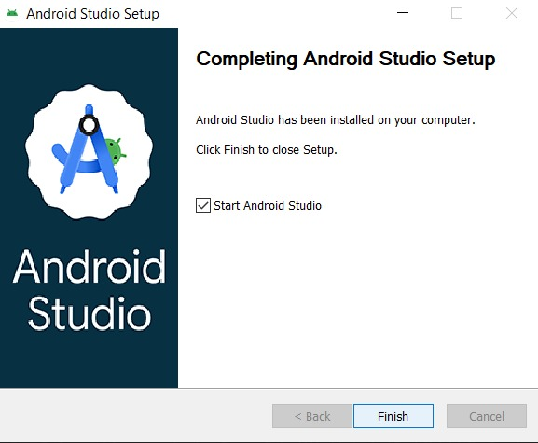

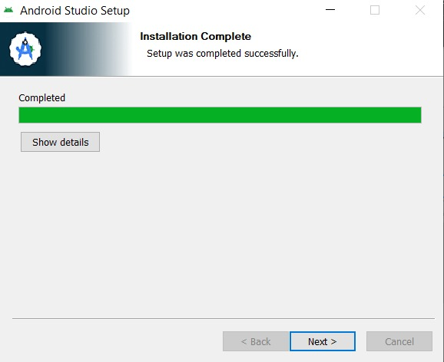

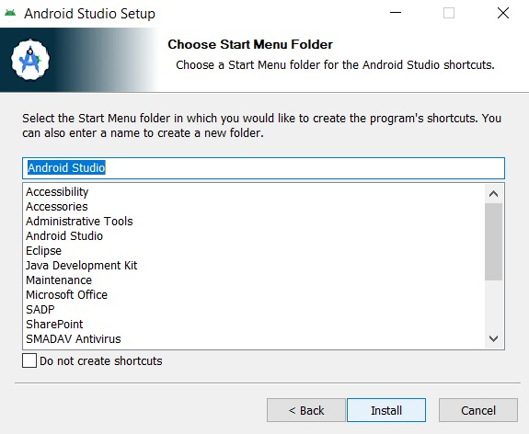

Tools/Software Used
Tool Used : Android Studio (with Kotlin/Jetpack Compose)

Personal Reflection
Reflection (Less than 50 words):
Through developing the SchoolLink app, a student should learn mobile application development, user interface design, navigation between screens, debugging, and testing on a real device. The project also builds problem-solving skills and demonstrates how technology can improve communication between schools and parents.

Week 2: Mobile Development Environment
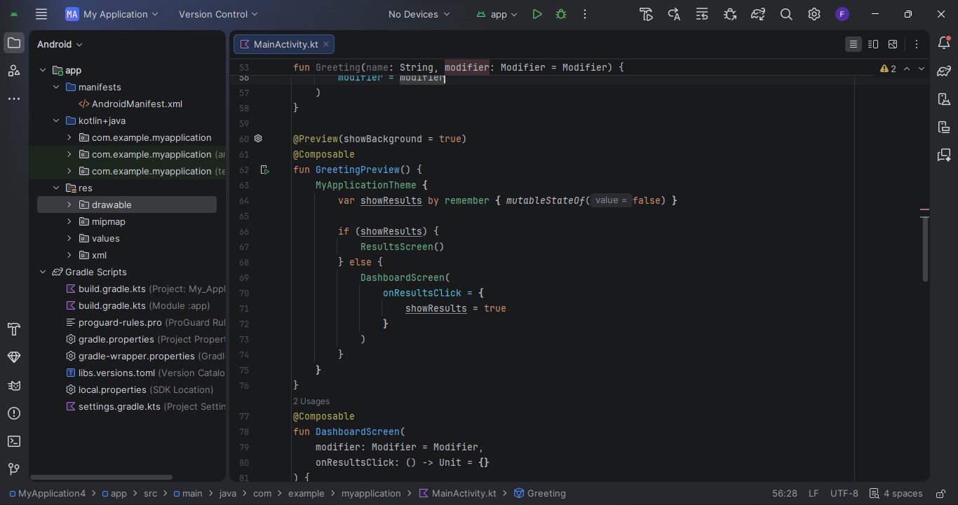
- Opening and setting up android studio
- Deciding and designing what i want to make

Week 3: User Interface Design
A screenshot of creating a user interface and linking then tasks together
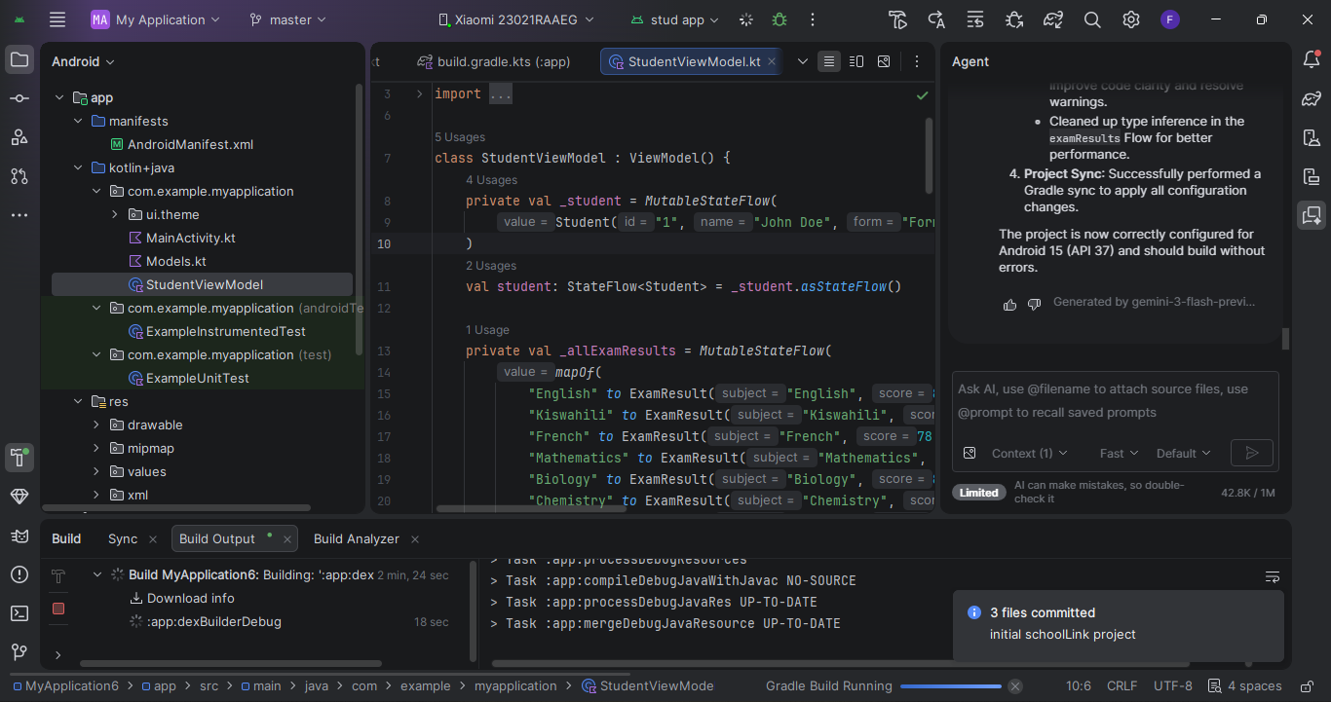
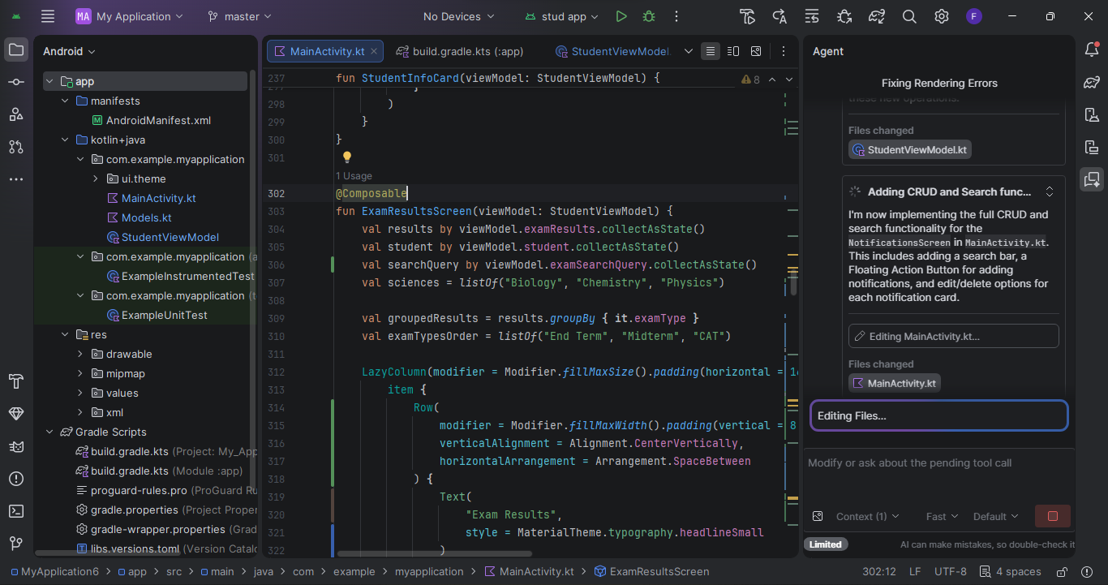
Tools used: Android studio, Java, Kotlin

Week 4: Event Handling and User Interaction
LINKING MY PHONE AND ENABLING ACTIVITIES TO RUN ON THE PHONE
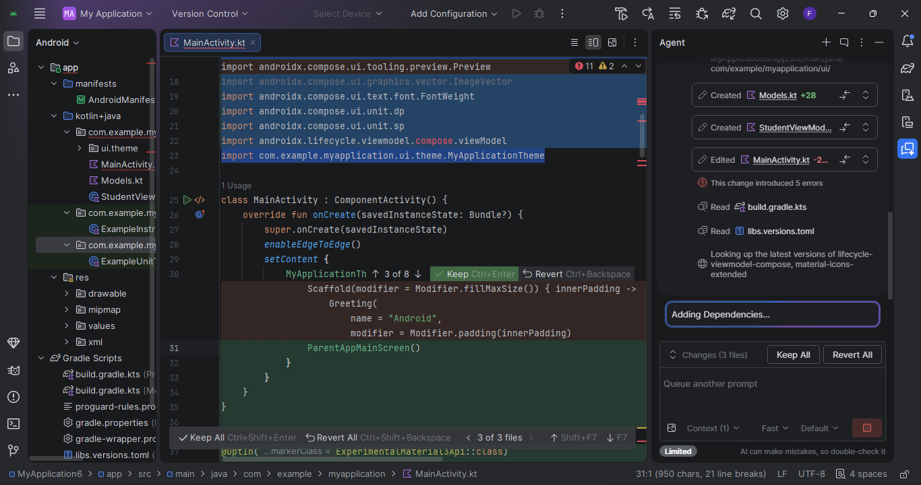

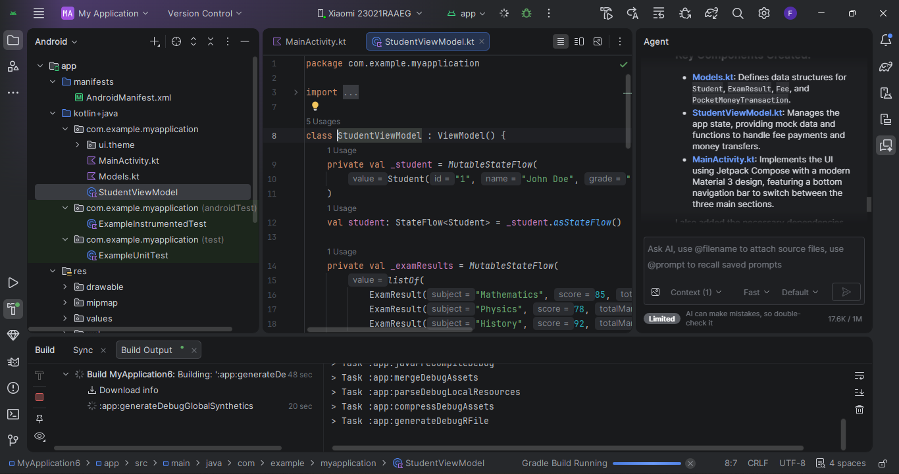

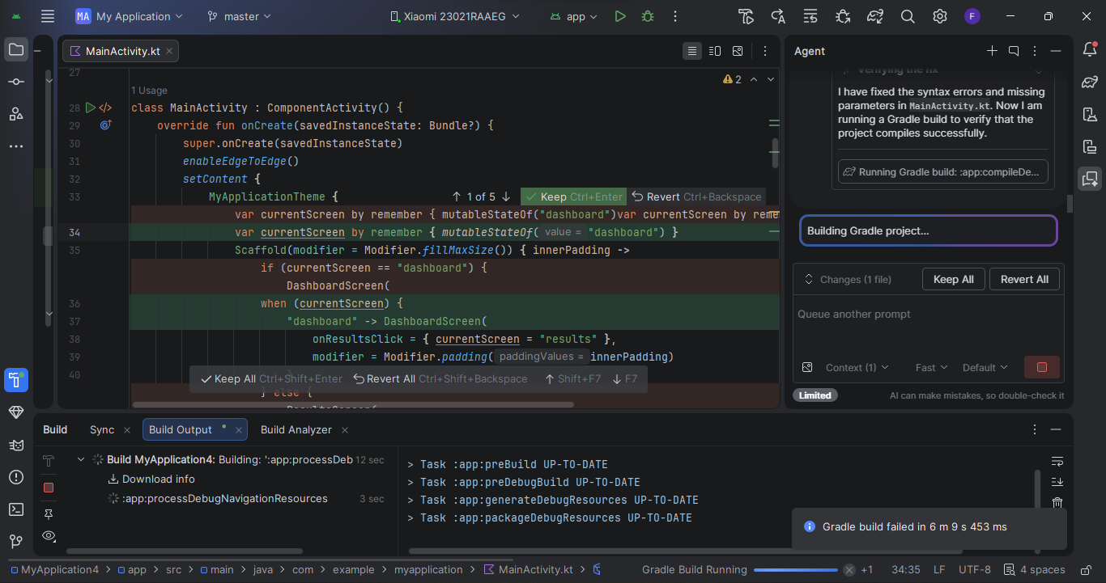

Week 5: Data Management
Activities Undertaken
During this week, I focused on data management aspects of the SchoolLink mobile application. I designed how student, parent, examination, attendance, and fee information would be stored and managed within the system. I also created data structures for handling user information and academic records.
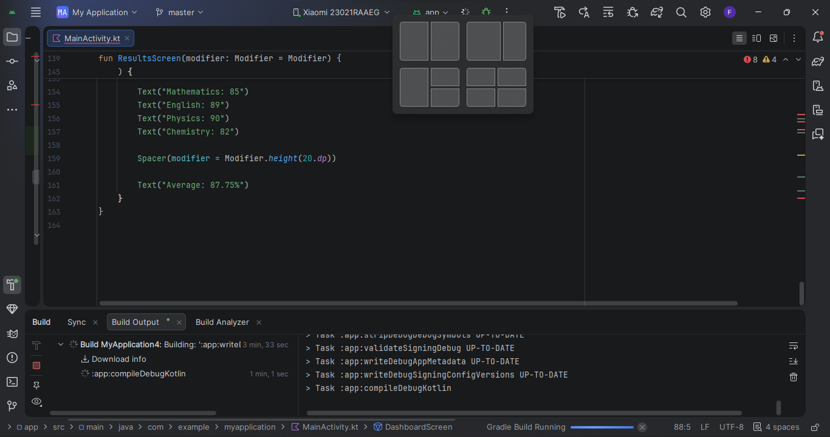
Managing data in my school app like the results
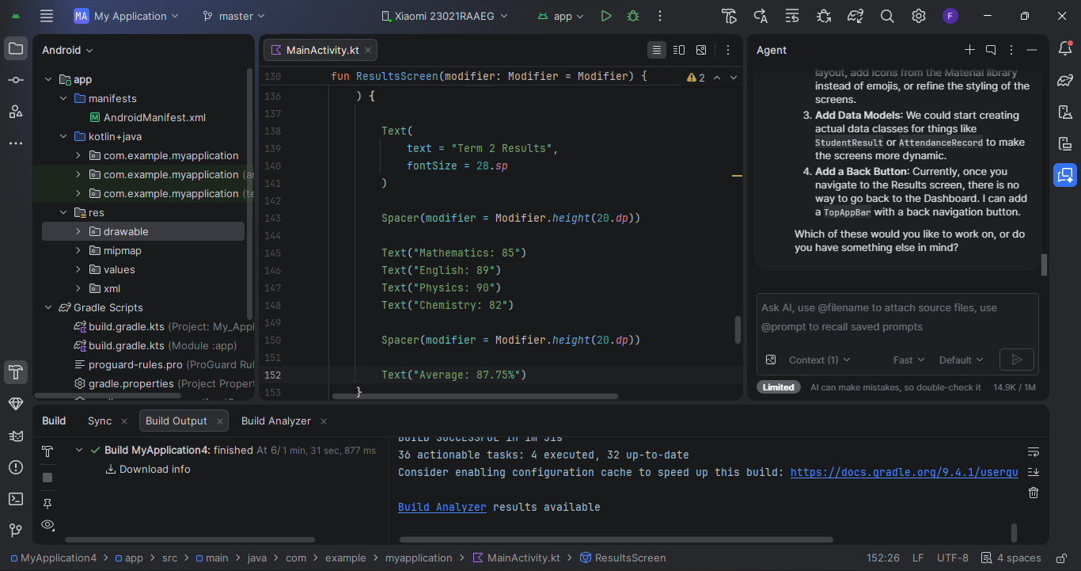
Tool Used
Android Studio
Kotlin Programming Language
Jetpack Compose
Firebase Real-time Database (planned database solution)
Documentation
Data management is an important component of the SchoolLink application because it enables the storage, retrieval, and updating of information. The application is designed to manage student records, examination results, attendance reports, fee balances, and pocket money transactions. Data is organized into different categories to ensure efficient access and security. Proper data management helps maintain data accuracy, consistency, and reliability within the system.
Skills Learned
Data organization and structuring
Database planning and design
Managing application data using Kotlin
Understanding data storage concepts in mobile applications
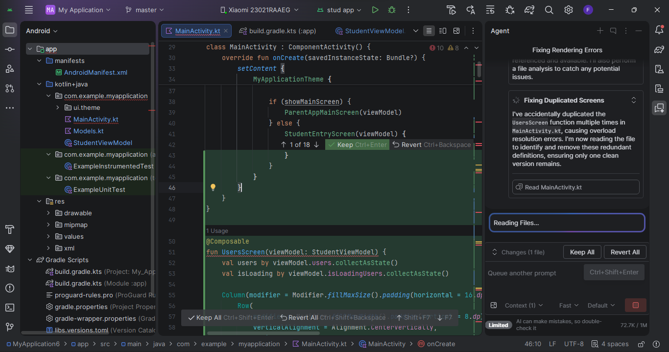

Week 6: Networking and APIs
Activities Undertaken
During this week, I studied networking concepts in mobile application development. I implemented a network configuration file and explored how the application would communicate with an online database to retrieve and update information such as examination results, attendance records, fee payments, and pocket money transactions.
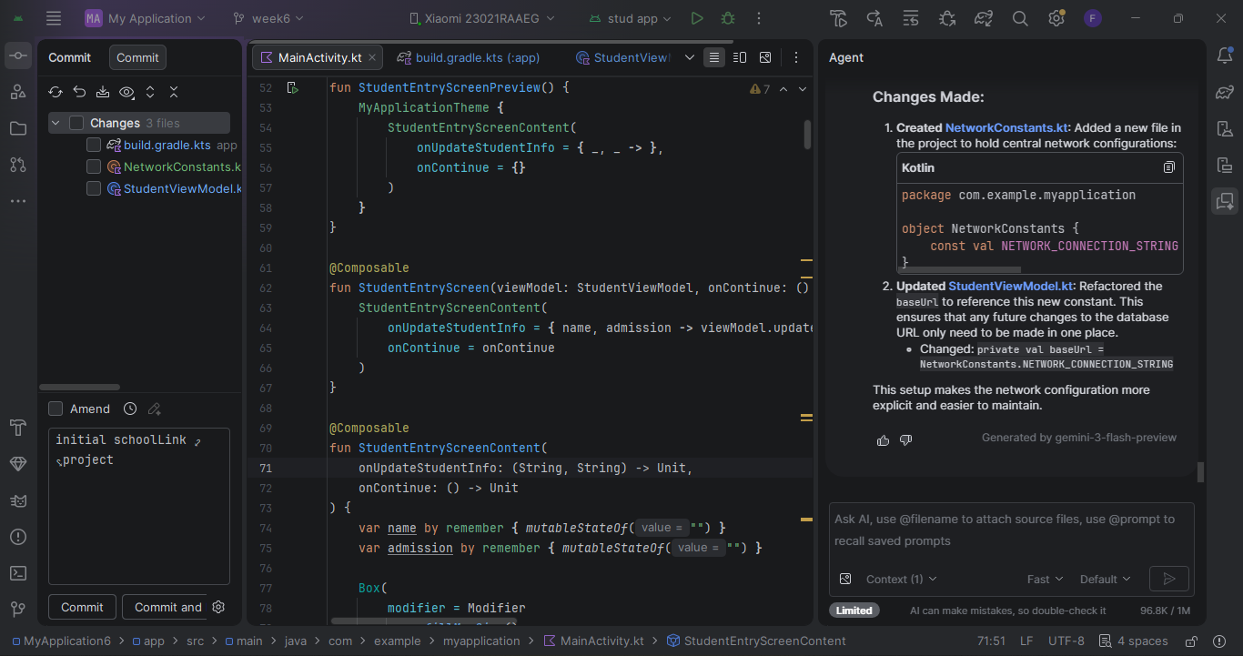
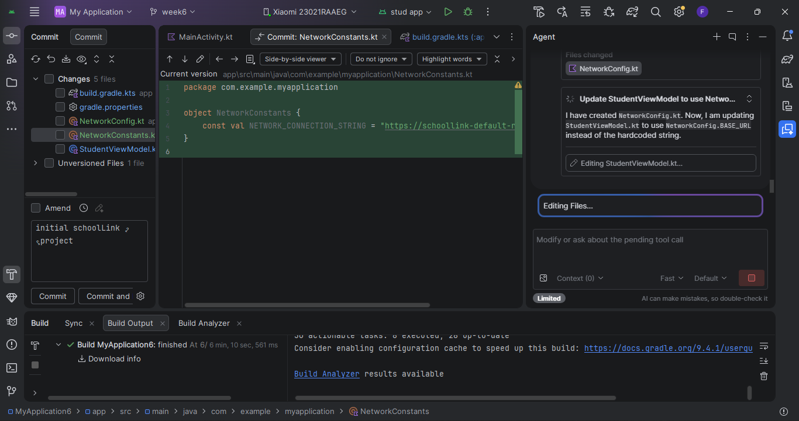
Code showing it's android studio with network connection string
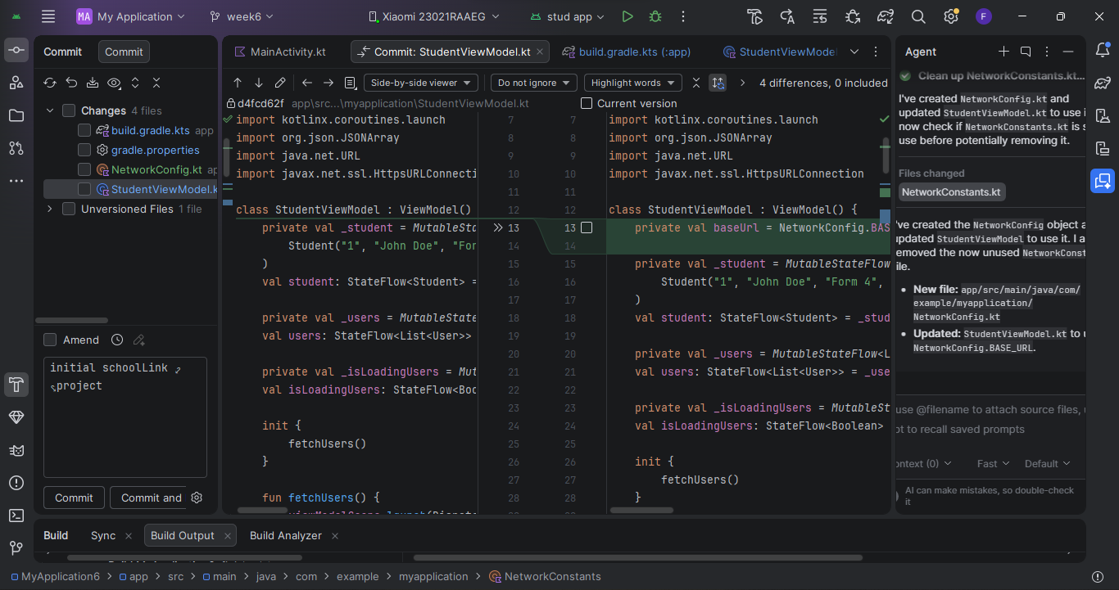
Screenshot of the code with connection string.
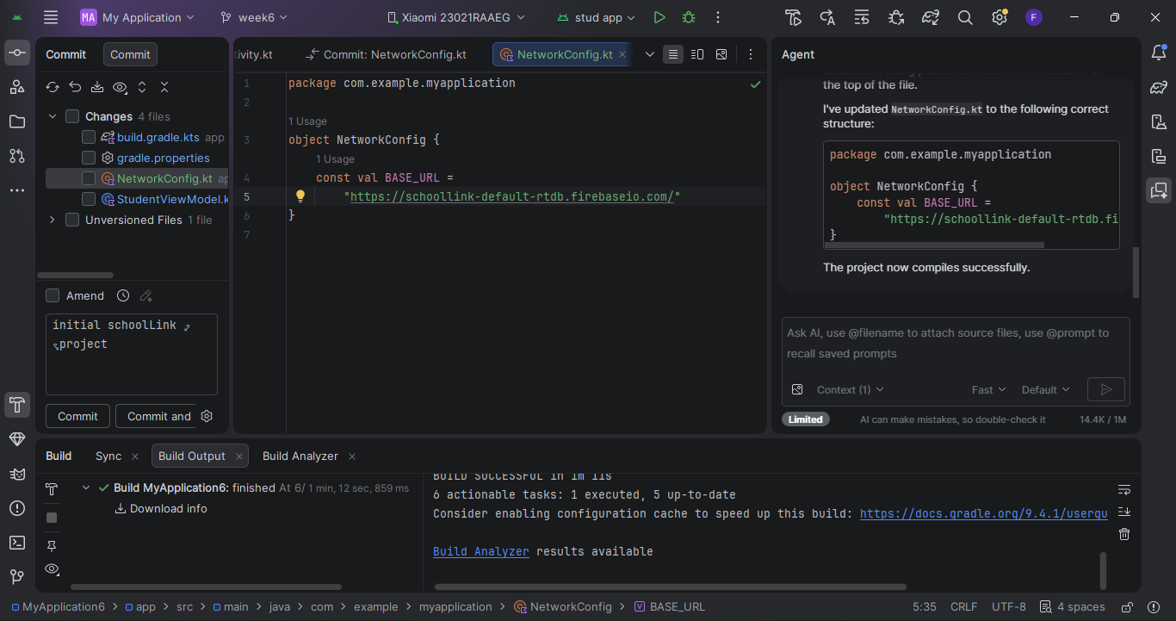

Tool Used
Android Studio
Kotlin Programming Language
Internet Connectivity
Firebase Realtime Database (planned)
Why the App Requires Networking (Less than 20 Words)
SchoolLink requires networking to retrieve results, process payments, send pocket money, and receive school updates.
Skills Learned
Mobile networking concepts
Client-server communication
API and database connectivity
Network configuration in Android applications
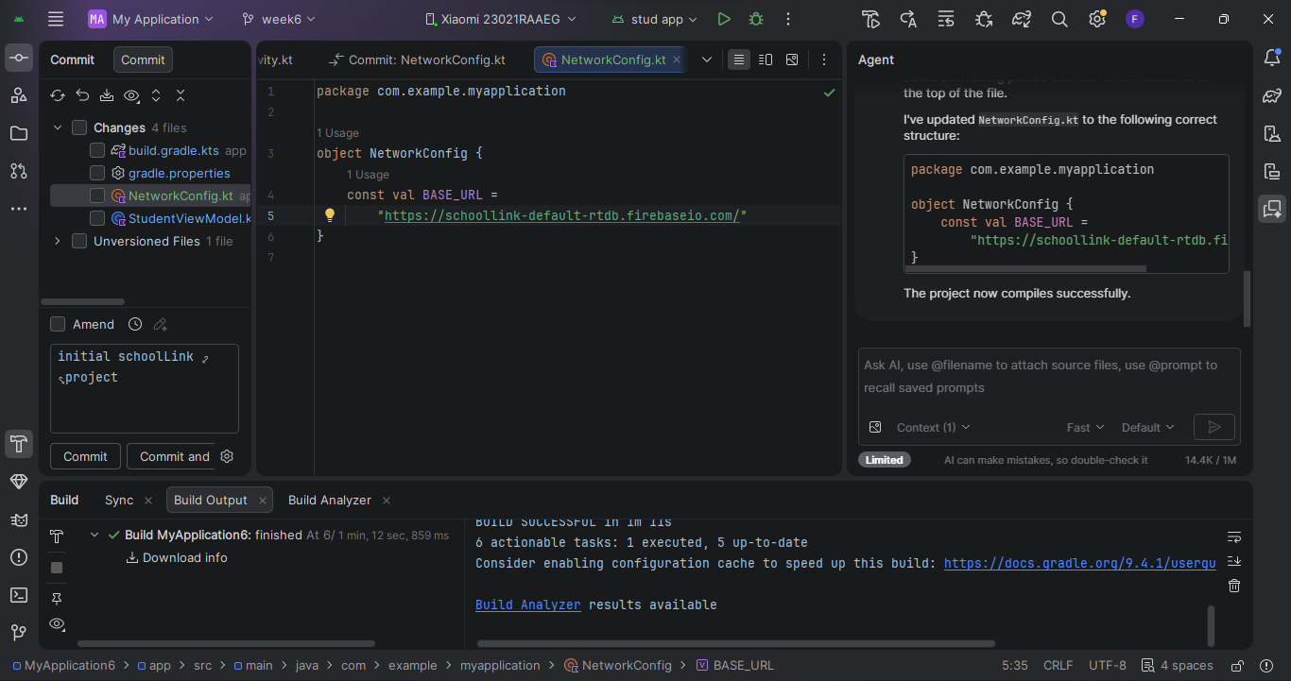

Week 7: Application Architecture
Activities Undertaken

During this week, I designed the application architecture for the SchoolLink mobile application. The architecture defines how different components of the system interact, including the user interface, application logic, database, and external services. This design helps ensure scalability, maintainability, and efficient communication between users and the system.

Tool Used
Android Studio
Kotlin Programming Language
Jetpack Compose
Draw.io / Microsoft Visio (for architecture diagrams)
Firebase Realtime Database (planned)

Application Architecture
The SchoolLink application follows a Three-Tier Architecture:

Presentation Layer
(Mobile App)
Login, Dashboard,
Results, Fees, etc.
Business Logic
Kotlin Application
Processing Requests
Authentication
Fee Calculations
Data Layer
Firebase Database
Student Records
Results
Attendance
Payments

Description of the Architecture
1. Presentation Layer
This is the user interface where parents, students, and school administrators interact with the application. It includes login screens, dashboards, results pages, attendance records, fee payment screens, and messaging features.
2. Business Logic Layer
This layer processes user requests and controls application functionality. It handles authentication, validation of user inputs, fee calculations, data processing, and communication between the interface and the database.
3. Data Layer
This layer stores and manages application data. It contains student information, examination results, attendance records, fee balances, pocket money transactions, and school announcements.

DOCUMENTATION
The three-tier architecture separates the user interface, application logic, and data storage components. This separation improves system organization, simplifies maintenance, enhances security, and allows future expansion of the SchoolLink application without affecting existing functionalities.

Skills Learned
Application architecture design

Three-tier client-server architecture

System component interaction

Mobile application planning and documentation

Reflection
Through designing the application architecture, I learned how different system components interact and how proper architectural design improves software quality, maintainability, scalability, and performance.
Week 8: Project Planning

Project Documentation: Parent School App Planning

Project Title
Project Planning for a Parent School App

Introduction
The Parent School App project was planned to improve communication between schools and parents by providing a digital platform for sharing academic updates, attendance records, fee information, announcements, and school events. The planning phase focused on defining project goals, gathering requirements, scheduling tasks, and allocating resources to ensure successful development.

Project Objectives
- To improve communication between parents and the school.
- To provide parents with real-time access to student information.
- To simplify the sharing of school announcements and events.
- To enable parents to monitor student attendance and academic performance.
- To create an easy-to-use and secure mobile application.

Activities Done

1. Requirement Gathering
- Met with school administrators, teachers, and parents to understand their needs.
- Identified key features required in the application.
- Documented functional and non-functional requirements.

2. Project Scope Definition
- Defined the features to be included in the first version of the app.
- Set project goals, deliverables, and timelines.
- Identified project constraints and assumptions.

3. System Planning
- Designed the overall system architecture.
- Planned user roles such as Parent, Teacher, and Administrator.
- Developed the project workflow.

4. User Interface (UI) Planning
- Created wireframes and screen layouts.
- Planned navigation between different app pages.
- Reviewed designs based on stakeholder feedback.

5. Database Planning
- Identified data to be stored, including student records, attendance, grades, fee balances, and announcements.
- Designed the database structure and relationships.

6. Risk Assessment
- Identified possible risks such as data security, internet connectivity, and user adoption.
- Developed strategies to minimize identified risks.

7. Project Scheduling
- Broke the project into manageable tasks.
- Assigned responsibilities to team members.
- Developed a project timeline with milestones.

8. Testing Plan
- Planned functional, usability, and security testing.
- Prepared user acceptance testing (UAT) procedures.

Tools Used
Tool | Purpose
Microsoft Word | Project documentation
Microsoft Excel | Project scheduling and budgeting
Trello | Task management and progress tracking
Figma | UI/UX design and wireframing
Draw.io | System flowcharts and diagrams
Google Meet | Stakeholder meetings and discussions
Google Drive | Document storage and collaboration
Gantt Chart | Project scheduling and milestone tracking

Skills Attained

Technical Skills
- Project planning and scheduling
- Requirements gathering and analysis
- UI/UX planning
- Database planning
- Risk management
- Documentation
- Task management

Soft Skills
- Communication
- Team collaboration
- Problem-solving
- Time management
- Leadership
- Stakeholder engagement
- Decision-making

Digital Skills
- Use of project management tools
- Wireframing and prototyping
- Document creation and organization
- Online collaboration
- Project tracking and reporting

Expected Outcomes
- A well-defined project plan for the Parent School App.
- Improved communication between parents and the school.
- Efficient tracking of student attendance, grades, and fee payments.
- Faster sharing of announcements and school events.
- Enhanced parent involvement in students' academic progress.

Challenges Encountered
- Gathering requirements from different stakeholders with varying needs.
- Balancing project scope with available time and resources.
- Ensuring data privacy and security requirements were addressed.
- Coordinating schedules for planning meetings.

Lessons Learned
- Involving stakeholders early improves project outcomes.
- Clear planning reduces delays during development.
- Effective communication is essential for successful project execution.
- Proper documentation supports better teamwork and project tracking.
- Risk planning helps prevent potential project issues.

Conclusion
The planning phase of the Parent School App established a clear roadmap for developing a secure and user-friendly application that strengthens communication between schools and parents. Through activities such as requirements gathering, system design, scheduling, risk assessment, and documentation, the project team gained valuable technical, organizational, and communication skills that support successful project implementation.

Week 9: Device Features and Sensors

Introduction

During Week 9, the development of the Parents Link mobile application focused on learning how Android applications interact with smartphone hardware. The class covered device features such as the camera, GPS, and sensors, as well as the permissions required before an application can access these resources. These concepts are important because they make mobile applications more interactive, useful, and user-friendly.

Activities Carried Out

This week, I studied the different hardware features available on Android devices and evaluated how they can be incorporated into the Parents Link application. I learned how applications communicate with the device camera, GPS, and other sensors through Android APIs. I also explored the concept of runtime permissions, which require users to grant permission before an application can access sensitive features such as the camera or location services. This knowledge is essential in ensuring that the application respects user privacy while providing useful functionality.



I further analyzed how these features can improve the Parents Link application. The camera can be used to allow parents and teachers to upload profile pictures, attach images of school activities, or share important documents. GPS functionality can help users identify the location of the school during meetings, events, or emergencies, while future integration with Google Maps can provide accurate navigation. These planned features will improve communication between parents and the school.

Another area of focus was understanding Android development best practices. I learned the importance of requesting only the permissions that are necessary, handling denied permissions gracefully, protecting user privacy, and minimizing battery consumption when using location services. These practices will help ensure that the Parents Link application remains secure, efficient, and reliable.

Skills Acquired

By the end of the week, I had gained a better understanding of Android device feature integration and how these features can be applied in a real-world application. I improved my knowledge of runtime permissions, camera integration, GPS functionality, and Android development practices. I also learned how proper planning before implementation makes it easier to integrate advanced features into an application.

Challenges Encountered

One of the main challenges was understanding how Android manages runtime permissions and how they should be implemented correctly. I also found it challenging to understand how GPS retrieves location data accurately and how camera functionality can be integrated with Firebase storage. Since these features involve multiple Android components, they required additional research and practice.

Solutions

To overcome these challenges, I referred to the class notes and Android documentation to understand the implementation process. I also reviewed examples of camera and GPS integration in Android Studio and planned how these features would fit into the Parents Link application. This preparation has made it easier to proceed with implementation in future development stages.

Conclusion

Week 9 was an important milestone in the development of the Parents Link mobile application. Although the camera and GPS features have not yet been fully implemented, I successfully understood their purpose, requirements, and how they can improve the application. The knowledge gained during this week will guide the next phase of development, where these device features will be integrated to create a more practical, interactive, and user-friendly application for parents, teachers, and school administrators.

Week 10: Notifications and Background Services

Same as week 1

Week 11: Mobile Security

Same as week 1

Week 12: Testing and Debugging

Same as week 1

Week 13: Application Deployment

Same as week 1

Week 14: Final Project Presentation

Same as week 1

Semester Project Tracking

Project Title

Project Objectives

Project Requirements

Development Milestones

Testing Results

Lessons Learned

Future Improvements

End of Semester Reflection

Summary of Skills Acquired

Most Interesting Topic

Major Challenges Faced

How Challenges Were Overcome

Professional Growth Achieved

Overall Course Experience

Final Approval
Student Name: __________________________
Student Signature: ______________________
Date: _________________________________
Lecturer Name: _________________________
Lecturer Remarks: _____________________
Date: _________________________________

